**Climate Action Information**

**What is climate action?**

Climate action “means **stepped-up efforts to reduce greenhouse gas emissions and strengthen resilience and adaptive capacity to climate-induced impacts**, including: climate-related hazards in all countries; integrating climate change measures into national policies, strategies and planning.

**Why is climate action caused?**

Climate change is caused by human activities and is threatening the way we live and the future of our planet. By addressing climate change, we can build a sus- tainable world for everyone.

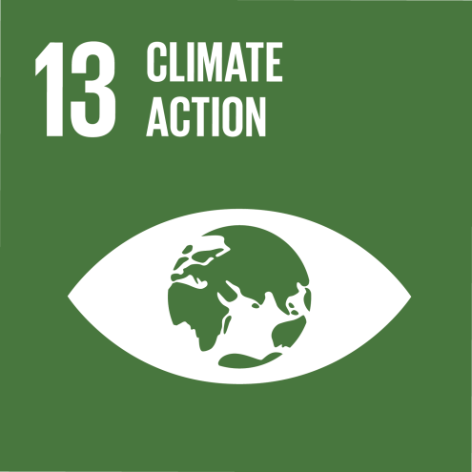

**What are some examples of climate action?**

* Make your voice heard by those in power. ...
* Eat less meat and dairy. ...
* Cut back on flying. ...
* Leave the car at home. ...
* Reduce your energy use, and bills. ...
* Respect and protect green spaces. ...
* Invest your money responsibly. ...
* Cut consumption – and waste.

**What does climate action focus on?**

It explains developments in **emission reduction and mitigation efforts**, assessing the impact of national climate pledges in relation to long-term emissions goals.

**Why is Climate Action important for economy?**

Every year, **climatic disasters cause human suffering as well as large economic and ecological damage**. Over the past decade, direct damages of such disasters are estimated to add up to around US$ 1.3 trillion (or around 0.2% of world GDP on average, per year).

**The solution for climate actions –**

**Changing our main energy sources to clean and renewable energy** is the best way to stop using fossil fuels. These include technologies like solar, wind, wave, tidal and geothermal power. Switch to sustainable transport. Petrol and diesel vehicles, planes and ships use fossil fuels.

**The 3 most important solutions to prevent climate actions are –**

Some of the most promising ways to mitigate climate change are what we call “natural climate solutions”: the conservation, restoration, and improved management of land, in order to increase carbon storage or avoid greenhouse-gas emissions in landscapes worldwide.

**How can we stop climate change actions?**

Start with these ten actions to help tackle the climate crisis.

1. Save energy at home. ...
2. Walk, bike, or take public transport. ...
3. Eat more vegetables. ...
4. Consider your travel. ...
5. Throw away less food. ...
6. Reduce, reuse, repair & recycle. ...
7. Change your home's source of energy. ...
8. Switch to an electric vehicle.

**This edition of the Goal of the Month editorial focuses on SDG 13, climate action. COP 27 resources and key events to watch. Click here to learn more.**

**What is COP27?**

The [United Nations 27th Conference of the Parties (COP27)](https://unfccc.int/cop27?gclid=Cj0KCQjw48OaBhDWARIsAMd966DjoF49Z-uXKyBeF4WRS6cWrKKd-NlkTSP82EtzCg7wbjU8SlPajJEaArMtEALw_wcB) in Sharm el-Sheikh, Egypt, marks 30 years of the United Nations Framework Convention on Climate Change (UNFCCC) and seven years since the signing of the[Paris Climate Agreement](https://unfccc.int/process-and-meetings/the-paris-agreement/the-paris-agreement). The Egyptian COP presidency looks to reconvene signatories to address climate action, focusing on finance, just transition, and greater mitigation and adaptation ambitions.  A strategic combination of these approaches may yet lead to the necessary *sustainable* and replicable solutions.

**COP27 seeks renewed solidarity between countries, to deliver on the Paris Agreement. Climate change is a global emergency that goes beyond national borders. Read News. Donate Online. View Events. Services: Improve Preparedness, Respond to COVID-19 Risks.**

**What is the goal of COP27?**

Created to increase the continent's participation in voluntary carbon markets, the initiative aims to produce 300 million carbon credits annually on the continent by 2030, unlock $6 billion in revenue, and support the creation of 30 million jobs.

**What is a COP summit?**

COP is an international climate summit. Every year, world leaders gather to discuss climate change at COP, which stands for Conference of the Parties. Since 1995, the United Nations has brought together the 197 signatories to the UN Framework Convention on Climate Change (UNFCC) to work on how to tackle climate change.